**Functional Automation Framework technical document.**

**Introduction:**

This High level framework is build to test functionalities of any project on Chrome, Firefox & Internet Explorer(Can be scalable to any browser)

**Dependencies user:**

1.Selenium

2.TestNG

3.Poi

4.Junit

5.WebDriver manager

6.log4j

7.Extent reports.

**This project follows Page object model pattern design and has mainly three packages as shown in below screenshot.**

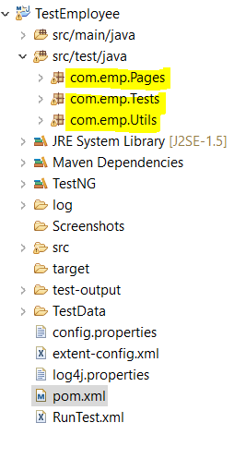

**The framework maintains test data into excel file which is present in TestData folder**

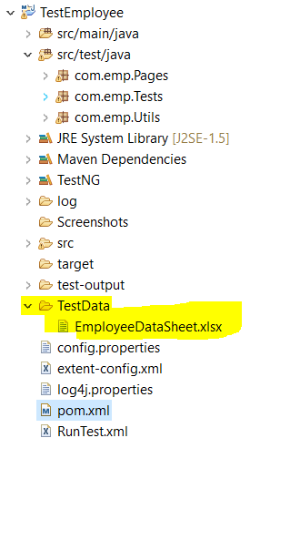

**Framework uses Extent reports for reporting and below is the sample report which I generated after testing.**

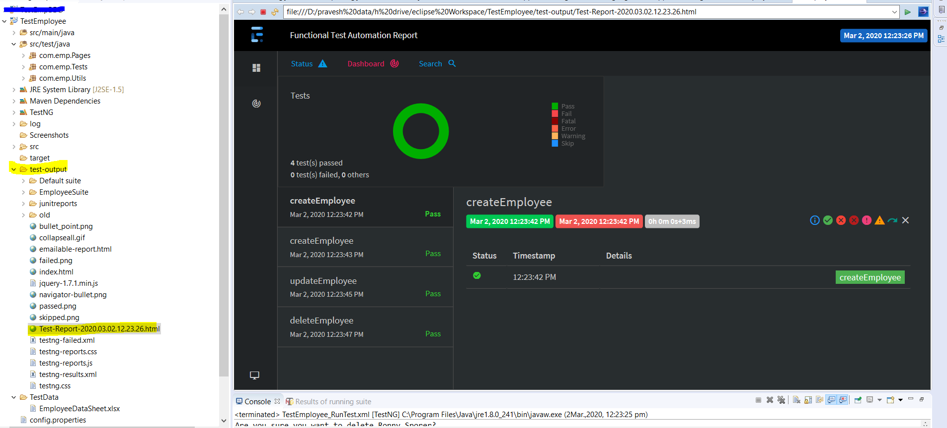

Framework takes screenshot and attach to report if any test failure occurs.

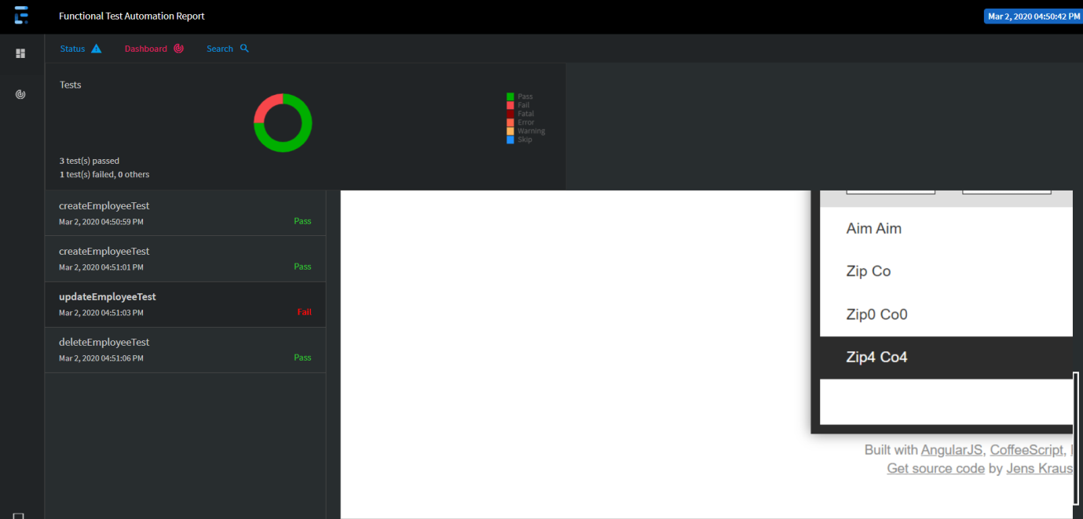

**Framework uses Log4j for logging actions in txt and html format, below is the log details.**

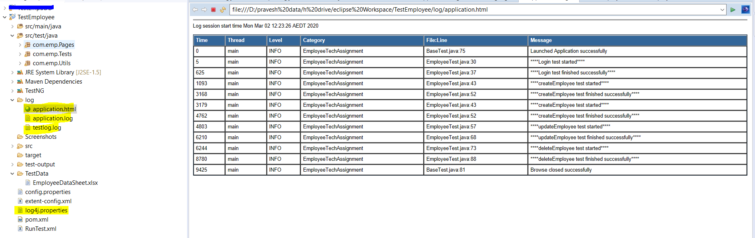

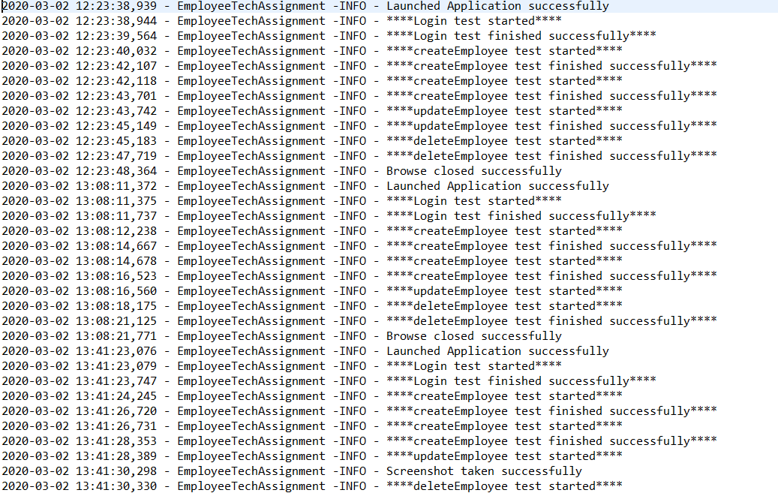

**Steps For Executing the framework.**

**Note:-**

**1.Before execution make sure you update, clean and build your project, so that all dependencies are present in the system.**

**2.Make sure you, provide proper data for update and delete flow in the excel file(Give those records which are present in the application)**

**3.Once you take project in computer the right click and do maven update, clean & build as show in below screen shot.**

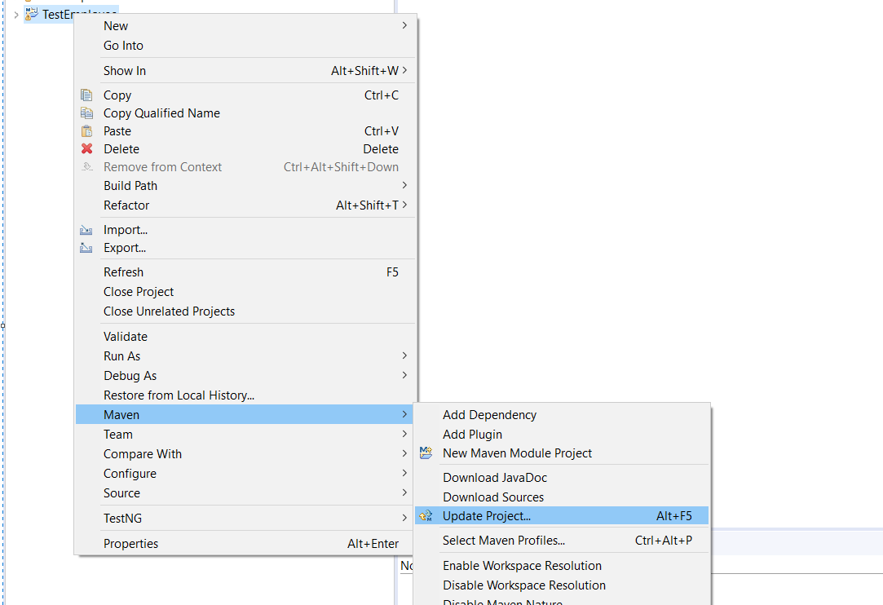

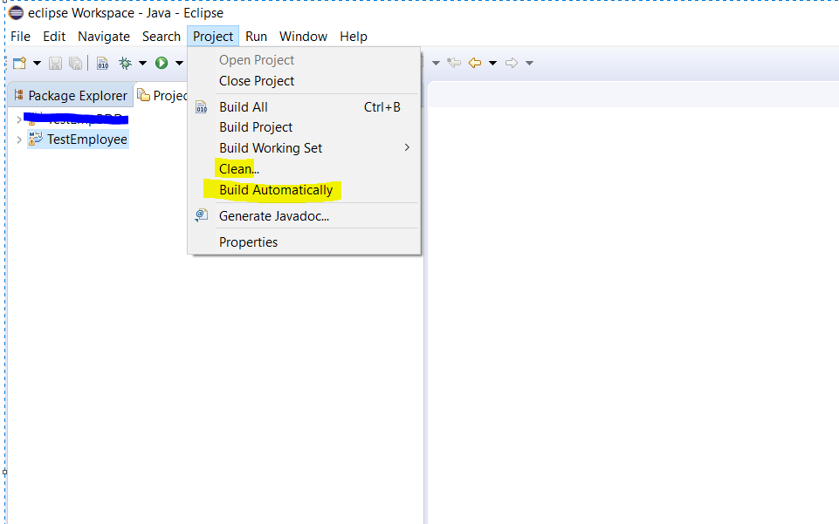

**For Executing the test Right click on RunTest.xml-> Run As-> TestNG suite.**

